Hebrew GRAMMAR Quest

2020-10-25

Table of Contents

# 

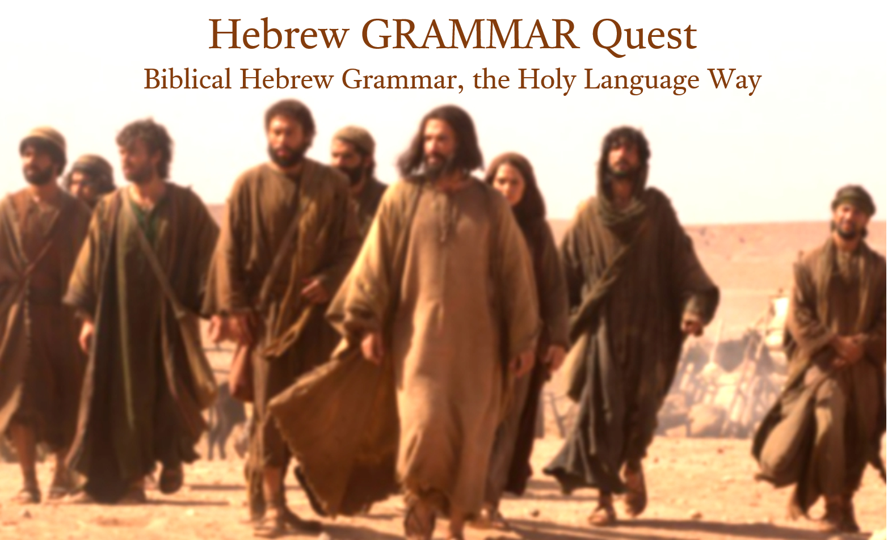

# Preface

Welcome to the preview version of Hebrew GRAMMAR Quest. Here, we are offering the first three lessons. The complete version, expected in late Spring 2021, will have thirty-five lessons.

We have two purposes for this preview:

1. Gather feedback on content and overall direction from Holy Language Volunteers before compiling all thirty-five lessons.
2. Eventually, these three lessons will comprise a demo/trial version of Hebrew GRAMMAR Quest made available to the general public.

Please do not hesitate to email errors, omissions, comments, or suggestions to [holylanguagecourses@gmail.com](mailto:holylanguagecourses@gmail.com) (in fact we’d rather hear about mistakes sooner rather than later!)

# Introduction



Many Hebrew grammar courses and books treat learning God’s Holy Language as if it were just another academic exercise. Listen to a lecture, read a chapter, take a test, and you’ll learn Hebrew.

At Holy Language, we believe that we learn best by doing. If you watched the original Hebrew Quest, you might remember Izzy Avraham, our founder, talking about feeding someone a fish, versus showing someone how to fish[1]. While other approaches may “feed” you Hebrew, learning Hebrew grammar, the Holy Language Way, means we’re going to show you how to teach yourself Hebrew and actively (dare we say “passionately”) ***engage*** with the Scriptures.

So what you’re reading right now is not just a textbook. It is an interactive guidebook to your PERSONAL Hebrew *Grammar* Quest!

## Relationship to Hebrew Quest

If you are familiar with our ministry, you likely know about our flagship course ***Hebrew Quest***. You may be wondering how Hebrew Quest and Hebrew GRAMMAR Quest work together.

We have FAQs in the appendix where we have a broader discussion, but in a nutshell, here is how we would characterize the two courses:

**Hebrew Quest** took you directly *to* the Hebrew Scriptures. It brought you in touch with the Hebraic side of the Bible that, perhaps, you had never experienced before. Maybe even now, you are building a closer friendship with what you now know as the “Tanach” or the “Hebrew Scriptures.”

**Hebrew GRAMMAR Quest** is designed to take you to the next stage of that friendship. It takes you *inside* the Hebrew Scriptures. Maybe it’s like progressing from a “good friend” to an “intimate” friend. So if you’ve completed some or all of Hebrew Quest and want to move to the next stage, you’re in the right place.

At the same time, the whole reason to study Biblical Hebrew Grammar is to read Biblical Hebrew, which is what **Hebrew Quest** is all about. So if God is placing within you an interest to learn the fundamentals so you can have a richer experience reading the Bible, you’re also in the right place!

## How the lessons are arranged

As we were thinking about how to design the book, we were struck by the similarities between traveling to Israel and learning Hebrew Grammar.

According to Dr. Wayne Stiles, to get the most out of a tour to Israel, one must actively undergo three stages of preparation[2]:

1. Practical Preparation - getting a “lay of the land”
2. Physical Preparation - getting in shape to do a lot of walking and combating jet lag
3. Spiritual Preparation - preparing to meet Yeshua in a life-changing way

### We believe these exact principles apply when learning Hebrew the Holy Language way!

## 1. Practical Preparation - getting a grammatical lay of the land

* In Israel, things like electrical outlets and certain customs are different. In the same way, Hebrew has characteristics and “customs” that are very different from English.
* This guidebook[3] has 35 lessons, each with a set of learning objectives we call “Seven Practical Points.”[4]
* This is not meant to be an exhaustive discussion of the topic, but an overview to get your journey started in the right direction.

But don’t feel that we’ve let you fend for yourself like a tourist in a Jerusalem traffic jam! We have a workout plan to get you into Hebrew Health, and we have established checks to make sure you have all the right equipment in your pack before you continue in your quest.

## 2a. Physical Preparation - getting Hebrew Healthy

* In Israel you do a lot of walking so you need to be in physical shape. Hebrew similarly has a lot of grammatical hills to climb, so we need to get Hebrew Healthy.
* To get in Hebrew shape, we’re not going to go to a physical gym, but there is a powerful piece of equipment that will build your Hebrew strength and endurance. It’s called **Anki**.
  + The majority of your work in this course will be doing what we call **Anki Aerobics**
  + There is an entire section in the Appendices devoted to Anki. It will show you how to get the program set up and how to get our custom **Hebrew GRAMMAR Quest** deck loaded. (***YOU MIGHT WANT TO DO THIS NOW***)
  + There will be three phases of Anki Aerobics with each Lesson: Vocabulary, Grammar concepts, and Study verse translation

## 2b. Physical Preparation - combating “the fog”

* One can’t fly halfway around the world and not experience jet lag. “The Fog”[5] is grammar’s version of jet lag.
  + Often, concepts you learn may not make sense until a lesson or two later. This is natural and we just need to go with it. We can’t avoid it completely, but we can control it.
  + Anki’s automatic review process[6] will be a huge help in working through The Fog
  + Each lesson will have a **Quest Quiz** for you to assess your progress. No grades are ever recorded in the course, but if you do get a lower score on a Quest Quiz, that could be an indication you aren’t quite ready to move on.
  + Most lessons will have an **Equipment Check** - We want to make sure you have the right supplies (i.e. grammar concepts from the previous chapter) in your backpack before you journey forward.

## 3. Spiritual Preparation - preparing to meet Yeshua in a life-changing way

### Hebrew GRAMMAR Quest is a spiritual journey!

A trip to Israel is not like any other “vacation” - it’s a spiritual journey. Unfortunately, all some do is see some cool sites and take some pictures. Imagine going all that way only to miss a tremendous opportunity to meet Yeshua in His extraordinary Land.

Similarly, suppose we view learning grammar as strictly an academic effort. We would risk missing insights Yeshua might want to teach us.

We have three aspects of being spiritually intentional in Hebrew GRAMMAR Quest: prayer, scripture reading, and encouragement. Since this is the most important part of the course, we’re going to take each of these aspects as individual sections.

## 3a. Spiritual Preparation: **Prayer** (Philippians 4:6-7[7])

* We want to begin each lesson with prayer
  + Each lesson will start with a suggested prayer topic
  + You can focus on this, or maybe something else that is on your heart
  + Pray and be open to what Yeshua may be teaching you

## 3b. Spiritual Preparation: **Scripture** (2 Timothy 3:16-17[8])

* In a “Biblical Hebrew” class, there should be a lot of “Bible”! We have “Ruth Pursuits” and Anki Study verses that will accompany each lesson.
* *Ruth Pursuits* - learning grammar concepts while learning Ruth 1, the beautiful passage of Scripture where a gentile bride commits herself to serve the God of Israel
* *Anki Study Verses*
  + You will read and begin to translate passages in Anki
  + You’ll also listen to the audio by Izzy to begin to hear the sound of the language
  + There are over 400 study verses!

## 3c. Spiritual Preparation: **Encouragement** (1 Thessalonians 5:11[9])

* Hebrew GRAMMAR Quest is not a quick sprint. It’s a long journey for which you will need intense training. It will be critical to stay encouraged to finish the quest!
* *Twelve Tribes Badges*[10]
  + Each of the Twelve Tribes has an emblem or symbol that has traditionally be associated with that tribe
  + Taken in total, all Twelve Tribes can teach us different aspects of our relationships with God and our neighbors
  + After two or three lessons, you will have the ability to “unlock” a new badge and learn more about what that tribe represents for us
  + We will ask you to confirm that you have completed all listed ACTIVities up to that point. Once you do this, you will receive your badge!
* *Graduation Process*[11] * For Hebrew GRAMMAR Quest, there will be a Graduation Process, similar to what we have for [Hebrew Quest](https://holylanguage.com/graduate.html) * At the end of each unit, you will be eligible for a certificate of completion * When you finish the entire course, we’ll send you a printable diploma and your choice of a clay lamp or Hebrew letters mug[12]

## ACTIVities

So you can see, this course is going to be jam-packed with things to do. In keeping with our philosophy that active learning is better than passive learning, collectively we call Anki, Ruth Pursuits, Quizzes and anything else like that ACTIVities.

When you see an ACTIVity, just remember that it’s all part of us showing you how to fish instead of just telling you about fishing!

### A typical lesson’s ACTIVities

1. **Practical Preparation** - Seven key learning objectives from each Lesson
2. **Physical Preparation**
   1. Video Warm-ups (starting with Lesson 3)
   2. Anki Aerobics
   3. Worksheets (selected lessons only)
   4. Quest Quiz
3. **Spiritual Preparation**
   1. Prayer before each Lesson
   2. Ruth Pursuit
   3. Anki Study Verses
   4. Badges and Graduation after selected lessons as encouragement

## ACTIVities Checklist

Here is a link to a [course checklist](https://docs.google.com/spreadsheets/d/1t0C7JlygyUqgF_aQWbhq7h3s_VDn0VuvISJn5mp-LdE/edit?usp=sharing). Save a copy to your personal computer or cloud drive and keep track of your progress!

### Let’s get started!

# 1 The Hebrew Aleph-bet

Knowledge of the Hebrew alphabet opens the door of understanding . . . Pastor Roger Valci[13]

 [14]

## Seven Practical Points for Lesson 1

1. Memorize the Hebrew Aleph-Bet
2. Understand that Hebrew is written and read from RIGHT to LEFT
3. Identify the group of five letters that have final/Sofit forms
4. Identify the group of six letters that can take a Daghesh Lene
5. Identify the group of four “guttural” letters that cause significant changes in spelling and punctuation (and the one additional letter that sometimes acts as a guttural)
6. Differentiate among “look-alike” letters
7. Note differences between “Seminary” and “Sephardic” pronunciation

Lesson 1 ACTIVities

## 1.1 The Hebrew Aleph-Bet



Almost every other grammar book would start with a lengthy description of each letter, how to write it, and how to pronounce it.

* But Hebrew GRAMMAR Quest is not just another grammar book
* With Hebrew GRAMMAR Quest, **we** are not going to teach you the Aleph-Bet…

*YOU* are going to teach yourself the Aleph-Bet using Anki

* This is not to say that we view learning the Aleph-Bet as unimportant.
  + Just the opposite: **you will not want to move on to lesson 2 until you have the Aleph-bet memorized.**

We believe learning is best accomplished when **you** are learning and challenging (and maybe struggling a bit) yourself. We are just here to give you some pointers, so your journey gets started in the right direction.

Notes:

* All letters you see in the picture of the Aleph-Bet above are classified as “consonants.”
  + Whereas English has the vowel letters (A, E, I, O, U) as a core part of the Aleph-Bet, Hebrew treats vowels differently
  + א and ע are not vowels but silent consonants; in Sephardic pronunciation, they take on the pronunciation of their associated vowel (if there is one)
  + We’ll talk about vowels in the next lesson
* This would be a great time to review the [Letter lessons in *Hebrew Quest*](https://holylanguage.com/letters.html)
  + Practical teaching on how to write the letter
  + Spiritual insights - what the letter teaches us

## 1.2 Hebrew is written and read from RIGHT-to-LEFT



Note the front of a Hebrew book is in the same location as the back of an English one:



* To our western eyes, this looks “backward” (but Israelis would say *we* are reading backward!)
* When reading Hebrew, always start at the “back” and go from RIGHT to LEFT
* **Hebrew Quest** discussion on Right to Left

## 1.3 Five letters have final (“sofit”) forms

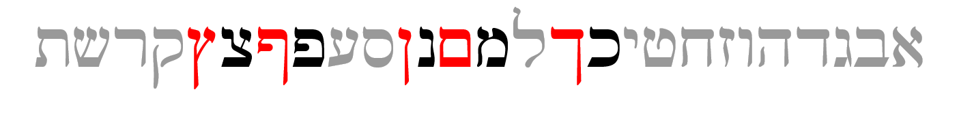

* Hebrew does not have capital letters the way English does, but it does have a generally similar concept
* Five letters take what are called “Final” or “Sofit”[15] forms when they appear at the END of a word
  + Those letters are in red text above
* The names of these letters is quite simple
  + Take the letter Kaf כּ, which is the first letter in the Aleph-bet with a sofit form
  + The final form is named Kaf Sofit ך. Same for Mem מ and Mem sofit ם and so on[16]
* The five letters that have these forms are the letters, Kaf, Mem, Nun, Pei, and Tsaddi: ך ם ן ף ץ
* You can remember the acronym, KiMNePaTZ, which is the made-up word you get when you string the five letters in a row
* The KiMNePaTZ sofit forms can look like other letters - your Anki work will give you practice with identifying look-alike letters

## 1.4 Six letters take a “Daghesh Lene”

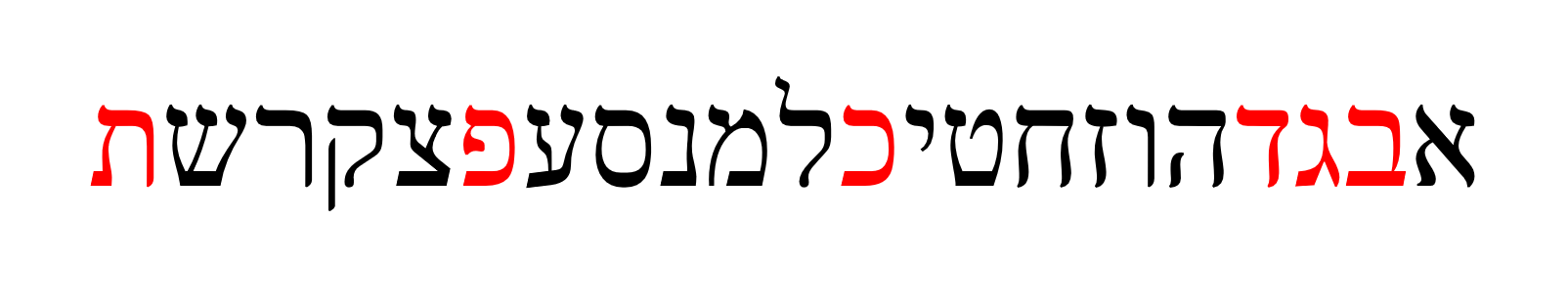

* The next sub-group of letters you need to study are the “BeGaD Kephat” letters[17]

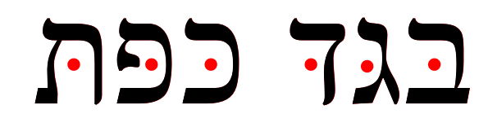

* The red dot in the above letters is called a **DAGHESH LENE**
* The Daghesh Lene is inserted into the middle of the consonant
  + The pronunciation of the letter is hard if the Daghesh Lene present or soft if not present
  + This ONLY applies to Bet - Gimmel - Dalet - Kaf - Pei - and Tav
  + We call then “BeGaD KePHaT” letters because that’s what you get when you pronounce the six letters together
  + Only these six can take a Daghesh Lene[18]
* At one time, all six of these letters had different pronunciations, but today, only three do: **בּ כּ פּ**
  + Since the letters without the Daghesh Lene want to be “lazy” - for example a weak ‘v’ instead of a strong ‘b’- our mnemonic for these is “BuCK uP! You Lazy Letters!”[19] 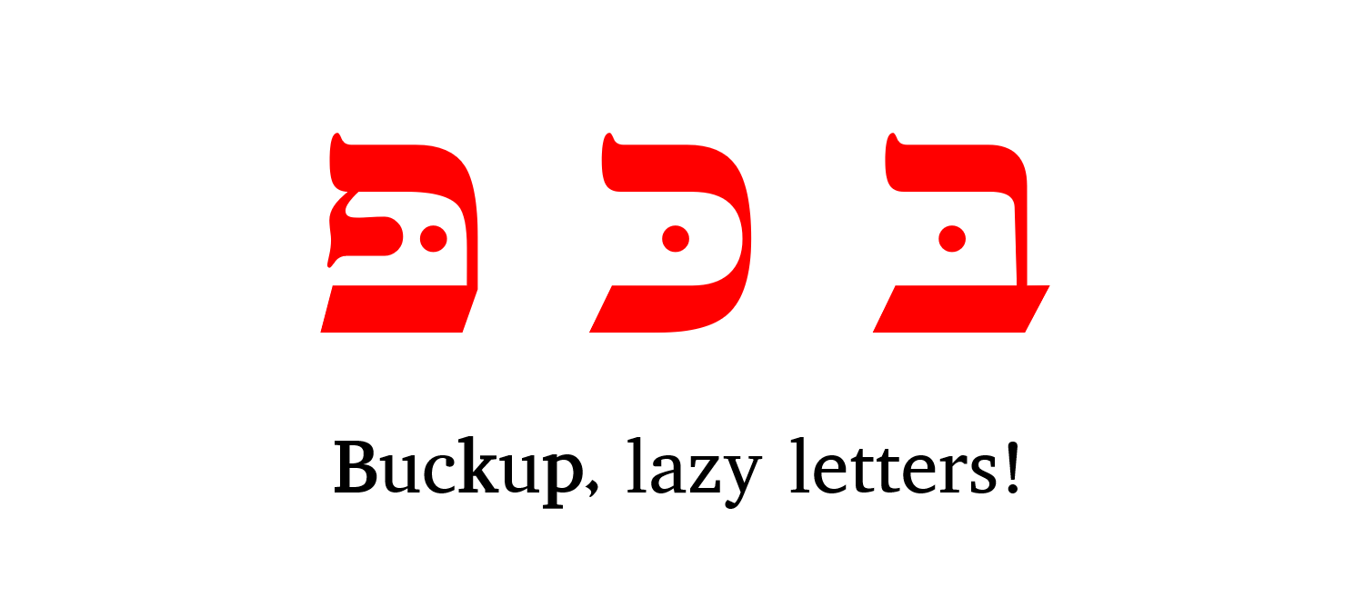
* Grammar rule: A Daghesh Lene is not used whenever the BDGKPT letter follows a Vowel

We’ll dig deeper into the Daghesh Lene and its twin, the Daghesh Forte, over the next few lessons.

## 1.5 We classify four letters as **Guttural Consonants** (and one is a sometimes-guttural)

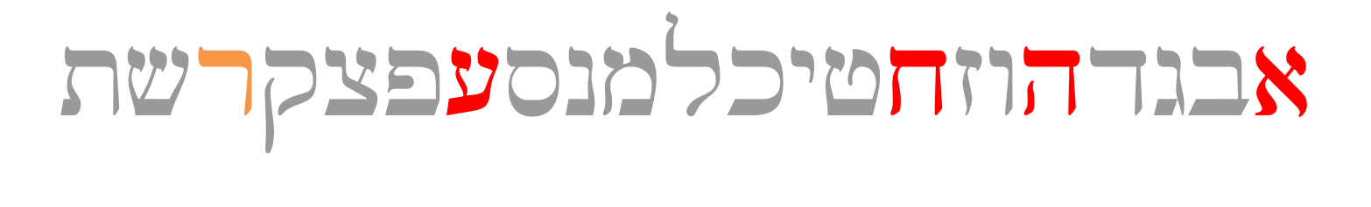

### Knowing the Gutturals and how they behave will turn out to be one of the most critical facets of Hebrew grammar

* There are four proper gutturals: Aleph, Hei, Chet, and Ayin (in red above)
* The letter Resh ר (in orange above) is not formally a Guttural; but since it can’t decide whether to behave or not, sometimes we include Resh with the other Gutturalsl
* We like to say that the gutturals will be our ‘problem children’ because they tend not to play nice with the other Hebrew rules
  + The good news is this bad-boy behavior of the gutturals and Resh is entirely predictable
  + We will learn this over the next few lessons (and indeed, the rest of the course)
* For now, memorize the four guttural consonants in red and Resh, the sometimes-guttural-like letter in orange.

## 1.6 Look out for look-alike Letters

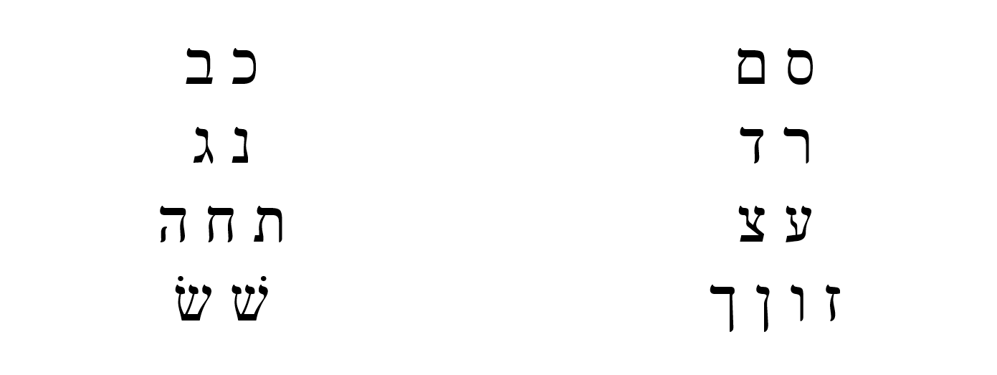

* Hebrew has many letters that can look similar, especially to someone just learning the Aleph-bet
  + The Anki deck will give you practice on distinguishing these.
  + Also, in Hebrew Quest, when Izzy reviewed the Aleph-Bet in lessons 2-11, he talked about each letter’s “twin” and how to spot the difference
  + We encourage you to revisit those [letter lessons](https://holylanguage.com/letters.html).



## 1.7 Sephardic vs “Seminary” Pronunciation

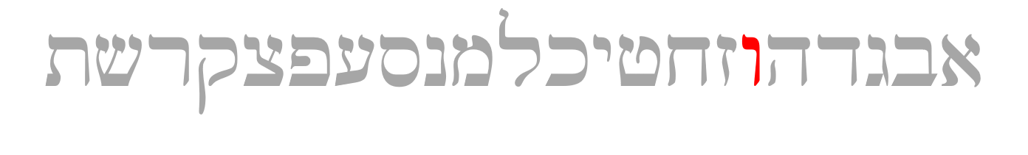

* There are some notable differences between what we might call academic or “seminary” Hebrew and “real-world” Hebrew.
  + Real-world Hebrew is based on Sephardic pronunciation[20]
* We’ve already talked about how only three of the Daghesh Lene letters need to “buck up”[21]
* Another difference between Sephardic and Seminary pronunciation is how to pronounce ו
  + In academia, the consonant receives the “w” sound and is called “Waw.”
  + In most non-academic circles, it receives the “v” sound and is pronounced “vav.”
* There are also significant differences in pronouncing vowels, which we will talk about in Lesson 2.
* For the most part, Hebrew GRAMMAR Quest will follow the Sephardic pronunciation
* Some terms like “Waw consective” and “wayyiqtol” are prevalent in the field of Hebrew Grammar, including modern Bible software (see image). 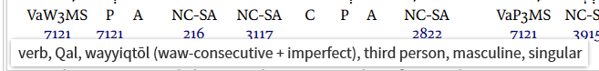
* This Guidebook and course will use “Adonai” or “the LORD” when we encounter the Tetragramaton[22].

## ACTIVity: Letter Writing

* Practice writing the letters individually using the [Letter Writing worksheet](https://drive.google.com/file/d/1JcX8kc6e-fKjtzkeE96AwoZFshEpx3ug/view)
* Practice writing the entire AlephBet until you can do it five times from memory.

## ACTIVity: Anki Aerobics

* Vocabulary - Learn (or relearn) the Aleph-Bet with Izzy   
* Grammar - Identify look-alike Hebrew letters  
* Verses - we won't be working on any verses just yet, but we will learn some grammar shorthand that we will use when we get to the study verses

## ACTIVity: Ruth Pursuit #1

[Ruth Pursuit](https://drive.google.com/file/d/1qcfTKAlTJGChC2eYCMhSbY2w-ibzCcDV/view?usp=sharing)[23] 1. Identify the four guttural letters (pink)[24] 2. Identify the one half-guttural (red) 3. Identify the six BeGaD KePHaT letters, both with and without the Daghesh Lene, for a total of 12 letters (green) 4. Identify the five final/sofit forms (blue) 5. Identify the remaining letters (yellow) * [(Ruth Answer Key #1)](https://drive.google.com/file/d/1vG8hKR50KcB0NclBnRWYPYMCEnobjgLc/view?usp=sharing)

## ACTIVity: Quest Quiz #1

[Open Quest Quiz #1 in a new window](https://docs.google.com/forms/d/e/1FAIpQLSeqHcE8PvfkOYbTu51cNO8sf-ln6CEnRrcTBUxM0EaeojSSsA/viewform)

# 2 Hebrew Vowels

And what is required first of all for training men for such a ministry is that the book should be given them in its very words [Hebrew, Aramaic, and Greek] as it has come from God’s hand and in the fullness of its meaning, as that meaning has been ascertained by the labors of generations of men of God who have brought to bear upon it all the resources of sanctified scholarship and consecrated thought.” —B. B. Warfield[25]

 [26]

## Seven Practical Points for Lesson 2

1. Memorize vowels that are not vowel letters
2. Learn vocal sheva and silent sheva
3. Memorize the vowel letters
4. Meet “defective” and “plene” spelling
5. Meet Daghesh Lene’s twin, Daghesh Forte
6. Know the rule for a Daghesh Forte
7. Know that the Gutturals and Resh reject Daghesh Forte

## Equipment Check

 Before continuing, can you name the following letters?

* The twenty-two Aleph-Bet letters
* The four BeGaD KePHaT letters
* The five KiMNePaTZ letters
* The four guttural letters and the one sometimes-guttural letter

## 2.1 Vowels that are not vowel letters

### Vowels come in three types: Long, Short, Reduced | Vowels come in five classes: A, E, I, O, U

Like the Aleph-bet, we are merely going to have to commit the table below to memory.

* The letter בּ is provided as a placeholder
* Say the vowel *after* saying the associated consonant[27] So the first vowel example is “baw” not “awb”.

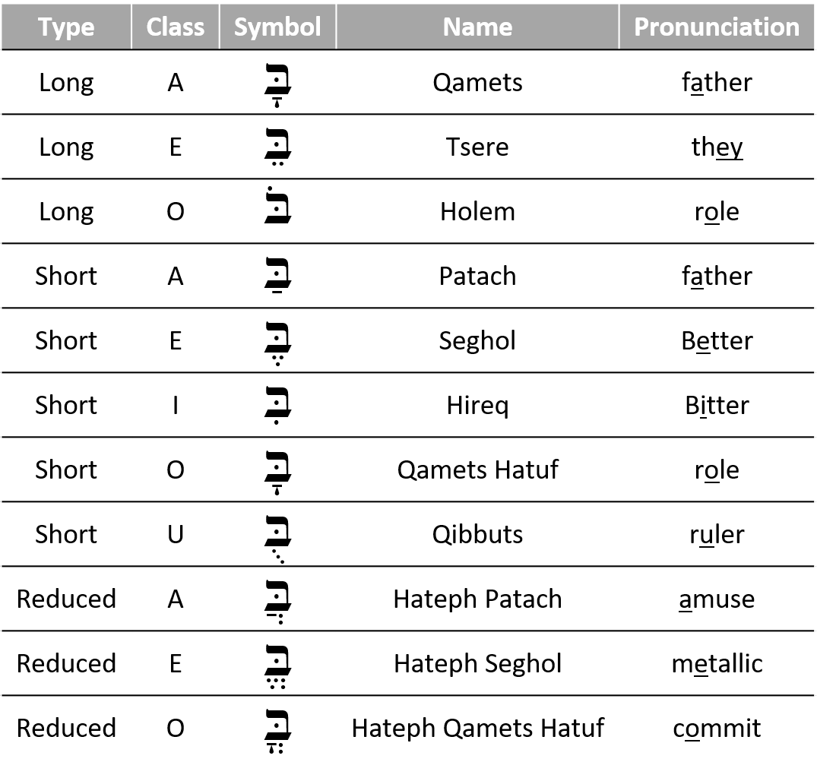

Notes:

* Future lessons will explain the difference between Qamets and Qamets Hatuf
* Only **gutturals** take the “Hateph” vowels - to make it easier, we can pronounce all three Hateph vowels like the A in Amuse
* You might see Kibbuts, Kibbutz, Qibbutz, and Qibbuts used interchangeably

## 2.2 Vocal and Silent Sheva

### Both are written as בְּ | VOCAL Sheva is a REDUCED vowel | SILENT Sheva is NOT A Vowel

* Vocal Sheva[28]
  + Only non-gutturals can take a Vocal Sheva
    - Gutturals reject the Vocal Sheva and take the Hateph vowels instead (see 2.1)
  + Pronounced like the A in Amuse (same as Hateph Patach)
  + Is a REDUCED Vowel
* Silent Sheva
  + Any letter can take a Silent Sheva
  + Silent/ No sound
  + Is NOT A Vowel
* *Both* Sheva mark the **END** of a syllable
* We will learn how to distinguish between the two kinds of Sheva in the next lesson

## 2.3 Vowel letters

### Vowel letters use a consonant plus a nikkud to form a vowel

Another table to memorize:

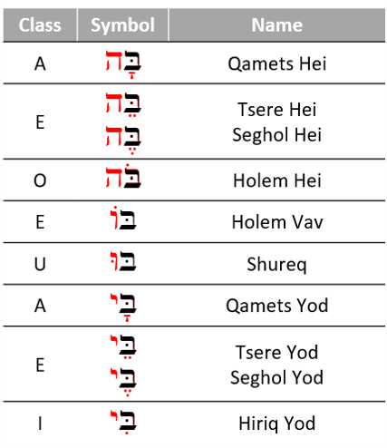

* Shureq is pronounced like Qibbuts (ruler)
* Hireq Yod is pronounced like the i in machine
* All others are pronounced like their non-vowel-letter counterparts
* Yod and Vav vowels - י,ו
  + These are Long Vowels that do not reduce
  + Therefore they are called “irreducible (unchangeable) long vowels”[29]
  + These occur in the middle or at the end of a word
* Hei Vowels - ה
  + Seghol Hei is a short vowel - the other Hei vowels are long
  + Hei vowels **ONLY** occur at the end of a word
  + Hei vowels are extremely common in Hebrew

## 2.4 “Defective” and “plene” spelling

### In “defective” spelling, letter vowels can sometimes drop their letter and take on the corresponding non-letter vowel. The meaning of the word doesn’t change.

This is the word for “laws” showing both “plene” spelling (left) and “defective” spelling (right):

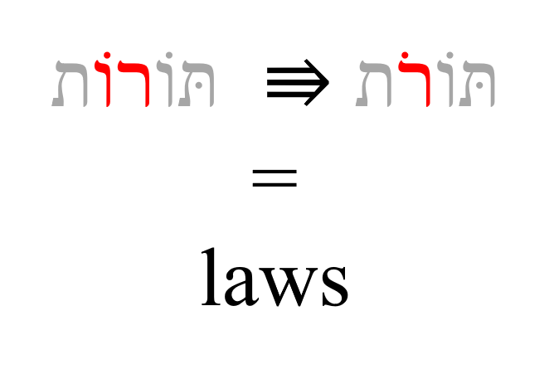

* Three vowel letters commonly take “defective” forms[30]
  + Hireq-Yod can drop the Yod and contract to Hireq
  + Holem-vav can drop the Vav and contract to Holem, as in the example above
  + Shuruq can drop the Vav and it’s associated nikkud and contract to Qibbuts

The qamets-hei ה ָ sometimes drops the final ה, leaving just the qamets under the now-final letter.

Over time, you’ll start to develop a mental checklist when you encounter something that doesn’t make sense. “Could this be a defective spelling?” will be one of those checklist items.

## 2.5 The Daghesh Forte

### A Daghesh Forte doubles the consonant

Notice the שּׁ in הַשָּׁמַיִם:

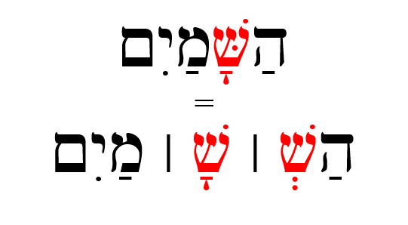

* Since שׁ is not a בגד כפת letter, we know this *cannot* be a Daghesh Lene, but it is a Daghesh **Forte**
* The letter with the Daghesh Forte both ends one syllable and begins the next syllable
  + If we were to syllabify הַשָּׁמַיִם, it would look something like the bottom line in the picture above (pronounce: hash-sha-mayim)[31]
* A similar word in English might be better = bet | ter
  + If we were to transliterate better into Hebrew hypothetically, it might look like: בּטֶּר*[32]
* Notice the syllable breaks in these words that have a Daghesh Forte: 
* Any consonant (except for Gutturals and Resh) can take a Dagesh Forte, including a בגד כפת letter, which can take either a Daghesh Lene or a Daghesh Forte
  + The “Buck-up” letters will take the **hard** pronunciation regardless of a Daghesh Lene or Daghesh Forte - See the final word אַתָּה in the image above

*Advanced tip:* When you see a Daghesh Forte, it often means that another letter has disappeared[33]. We will talk more about this later in the course.

## 2.6 Daghesh Forte Rule

### “A Daghesh is a Forte if, and only if, it’s preceded by a vowel [34]that is not a Sheva.” —John Beckman

That’s it. That’s the rule[35].

Examples:

* אַתָּה = Is the Daghesh preceded by a vowel that is not a Sheva?[36]
* בְּרֵאשִׁית = Is the Daghesh preceded by a vowel that is not a Sheva?[37]
* עַל־פְּנֵי = Is the Daghesh preceded by a vowel that is not a Sheva?[38]
* מַבְדִּיל = Is the Daghesh preceded by a vowel that is not a Sheva?[39]
* מִתַּחַת = Is the Daghesh preceded by a vowel that is not a Sheva?[40]

## 2.7 Gutturals and Resh reject Daghesh Forte

* We said in lesson one that the Gutturals don’t play nice with the other Hebrew Rules, and this rejection of the Daghesh Forte is one of those ways
* A Hebrew collision like this means something has to give - the gutturals tend to get their way - it’s like they have a force-field shielding them from other Hebrew grammar rules!



Figure 2.1: That’s no moon. That’s a Guttural!

* A large chunk of Hebrew GRAMMAR Quest will involve our learning to resolve these situations - more to come!

## Lesson 2 ACTIVities

* Complete Anki Aerobics for Lesson 2
* Practice writing the vowels using the [Vowel Writing worksheet/drill](https://drive.google.com/file/d/1ETPKE3u-XGfpNdKmlIr3P_DRbkOOlcI_/view?usp=sharing) See note[41]

## Ruth Pursuit

[(blank copy)](https://drive.google.com/file/d/1qcfTKAlTJGChC2eYCMhSbY2w-ibzCcDV/view?usp=sharing)

1. Identify the four UNCHANGEABLE LONG vowels that use YOD in Verse 1 (blue)[42]|
2. Identify the two UNCHANGEABLE LONG vowels that use VAV in Verse 1 (Green)
3. Identify QAMETS HEI in Verse 1. There is a TSERE Hei between Verses 5-10. Can you find it?[43] (Purple)
4. Identify the three LONG vowels in Verse 1 (that are not part of a vowel letter) (pink)|
5. Identify three of the five SHORT vowels in Verse 1 (that are not part of a vowel letter)[44] (red)
6. Five the three REDUCED/HATEPHH vowels, including Hateph Qamets Hatuf[45]. They are in verses 2-4. (grey)
7. One of the more common verbs in the Tanach is **וַיֹּאמֶר** , which means "(and) he said.
   * Vav-Patach-**Yod**-Daghesh Forte –וַיּ to start a verb means "And he (did or was something)
   * If we change the second consonant from a Yod to a **Tav**, we get –וָתּ, “and **S**he (did or was something).  
     * Thus, וַתֹּאמֶר means”and she said."  
     * Challenge: Find the five instances of וַתֹּאמֶר in Ruth Chapter 1[46] (yellow)
     + [Ruth Pursuit Answer Key #2](https://drive.google.com/file/d/1xtcXRb1PWbt-qkbVWW9yGfkC40_d8gtf/view?usp=sharing)

## Quest Quiz #2

[Open Quest Quiz #2 in a new window](https://docs.google.com/forms/d/e/1FAIpQLSeq_9Cy5IlAKDFy8nx9GNC3dfs5l5bJ_iX2FJ0Az7rPKXq5Jw/viewform)

## Claim your “12 Tribes” Badge!

If you have completed **all activities** in Lessons 1 and 2, you may claim the first of our “12 Tribes” badges[47].

[Check the requirements here](https://docs.google.com/spreadsheets/d/1t0C7JlygyUqgF_aQWbhq7h3s_VDn0VuvISJn5mp-LdE/edit?usp=sharing), then complete the certification and claim your badge below:

Loading…

# 3 Syllabification and Pronunciation

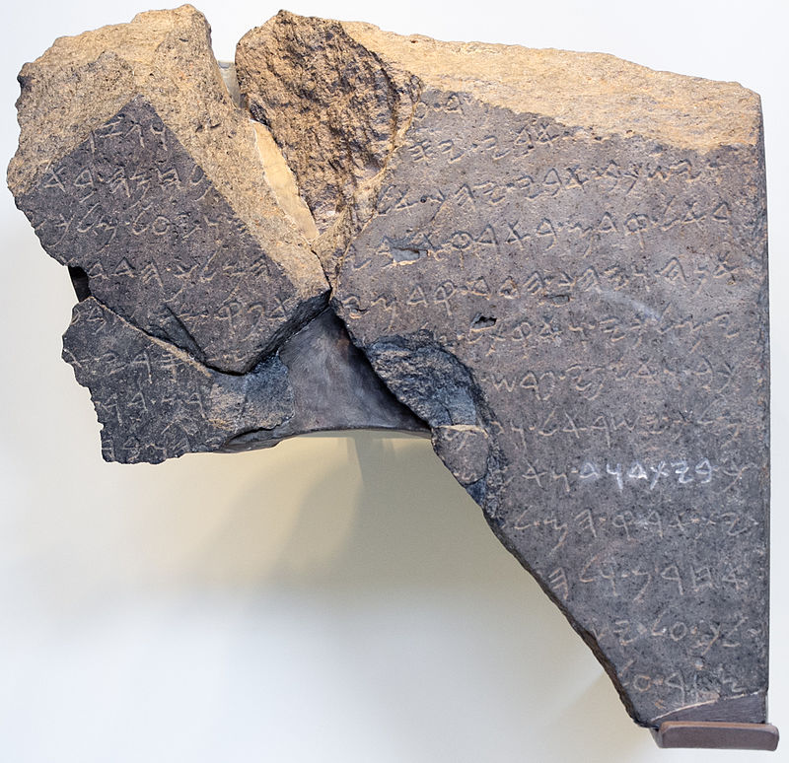 Originally, the Bible and other ancient documents, like the “Tel Dan Stele” pictured above[48], were written without spaces. In addition to vowels, the ancient scribes and readers organically adopted a system of syllables and accents. They knew where one word ended, and another began without needing to write it down.

What we call “Hebrew grammar” is truly an exciting journey into the system of spoken and written Hebrew, which had its formation thousands of years ago!

## Seven Practical Points for Lesson 2

1. Learn the two basic concepts of Hebrew Syllables
2. Learn the rules and terminology related to Hebrew Word Accents
3. Know the Three Rules for Recognizing Silent Sheva
4. Know the Four RulesRecognizing Vocal Sheva: Four Rules Gutturals Reject Vocal Sheva
5. Learn the primary Hebrew Diphthong
6. Understand Vowels and Syllable Preference
7. Learn three simple miscellaneous concepts: Qamets and Qamets Hatuf, Furtive Patach Quiescent Alef

## Equipment Check



Before continuing, can you describe the following concepts?

* The vowels that are not letters, including their type (long, short, reduced) and class (a,e,i,o,u)
* The vowels that are letters, including which are the “irreducible long” type
* The difference between a Daghesh Forte and a Daghesh Lene

### **The authors of Basics of Biblical Hebrew believe Lesson 3 could be the most challenging chapter in the book.**

Suppose you do not have the vowels and, chiefly, the vowel types memorized. In that case, this chapter will be all the more difficult.

Assuming you’ve checked your equipment as directed above, and everything is in tip-top shape for your Lesson 3 adventure, take your time. Work through the written material, then do a little Anki work and see if it starts to click.

If not, then come back here and re-read the material again. Then go back to Anki. If you find yourself getting frustrated, take a break, and come back to it later. Continue to work through “the fog.”

You absolutely must have the concepts from this lesson hard-wired before you continue to Lesson 4. The good news is that once you get this lesson down, the ones that follow will be relatively straightforward.

In addition to all of these new concepts, the authors have also seen fit to introduce a full set of vocabulary words AND study verses beginning with Lesson 3. So the overall workload will increase, starting with this lesson.

We’re praying for you in advance as we compile this section! Now, climb the mountain!

## 3.1 Hebrew Syllables

There are two basic concepts when it comes to Hebrew Syllables:

### Every syllable begins with one consonant and has only one vowel

### There are only open or closed syllables



We see the two basic concepts at play in this simple word (pronounced “da-var” and means word, matter, thing):

* The two syllables each begin with a consonant and have one vowel
  + דָּ starts with the consonant Dalet, and has one vowel, Qamets
    - This is also an example of an “open” syllable - open syllables end with a *vowel*, not a consonant
  + בָר starts with the consonant Bet and has one vowel, also a Qamets
    - This is an example of a “closed” syllable - closed syllables end with a *consonant*, not a vowel
* If you need to know how many syllables are in a Hebrew word, count the vowels
  + Remember that vowel letters, such as the Hiriq-Yod, and Diphthongs we will see later in this lesson, count as a single vowel unit

## 3.2 Hebrew Word Accents

### Most frequently, Hebrew words are stressed on the last syllable.

### If not, then the accent will be on the next-to-last syllable

Unlike English, Biblical Hebrew words are never stressed anywhere else[49].



* The word on the left is stressed on the last syllable
* The word on the right (pronounced “SAY-pher” or “SEH-pher” and means book, scroll, or document) is stressed on the next to last syllable
  + Some texts will place a mark over the syllable to be stressed (except when it is on the last syllable)[50]

### Tonic, Pretonic, and Propretonic Syllables

* We will encounter specific terms for a syllable’s position respective to the word’s accent
* Let’s use the plural of דָּבָר to illustrate: דְּ ׀ בָ ׀ רִים
  + The **Propretonic** syllable is two (or more) steps away from the accent = דְּ
    - Notice how the vowel changed from the Qamets in דָּבָר to a Vocal Shewa in דְּבָרִים
    - This vowel shortening of the propretonic syllable is called *Propretonic Reduction* and is extremely common in Hebrew
  + The **Pretonic** Syllable is the syllable immediately before the accented syllable = בָ
  + The **Tonic** syllable is the one with the accent = רִים[51]

## 3.3 Silent Sheva

Learn the three rules for differentiating a SILENT Sheva from a Vocal Sheva:

### SILENT when the previous vowel is short



### SILENT when the first of two consecutive Shevas *within a word*



### SILENT when at the end of a word

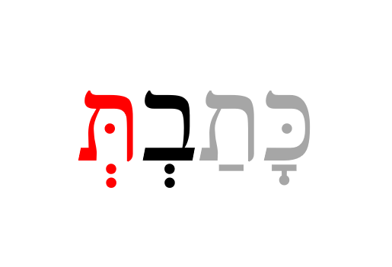

## 3.4 Vocal Sheva

Learn the four rules for differentiating a VOCAL Sheva from a Silent Sheva

### VOCAL when the initial Sheva in a word:



“buh-rei-sheet” and “buh-ra-cha”

### VOCAL when the second of two consecutive Shevas *within a word*[52]:



“mish-puh-tai”

### VOCAL when under a Daghesh Forte:



“ham-muh-la-kim”

### VOCAL after an unaccented long vowel:



This one may seem random, but it is relatively common with *long* vowels in a propretonic position[53] The word above is not kōṯ-vim but kō-ṯᵉ-vîm.

## 3.5 Hebrew Diphthong = Accented Patach-Yod-Hiriq



* The fundamental concept is that the diphthong is one vowel unit, which means it is only one syllable
  + We do not pronounce as “BUY-it,” but monosyllabic “BUYIT”; and not “sh-MY-im” but “sh-MYIM”

## 3.6 Vowels and Syllable Preference

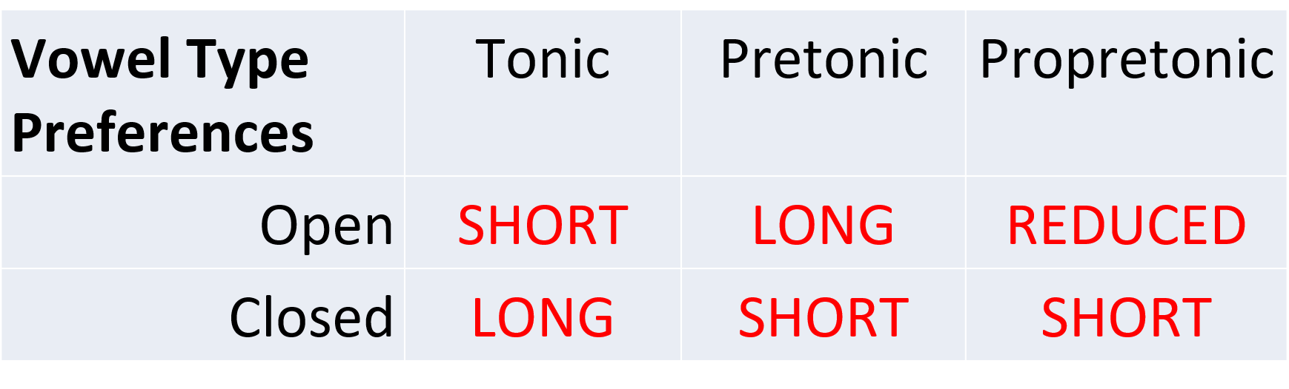

This table may seem like minutiae, but do yourself a favor: memorize it!

* Open/Propretonic *prefer* reduced vowels, but this is why the concept of unchangeable long vowels matter.
  + Go back and look at דָּבָר and דְּבָרִים
    - The vowel preference table explains why the vowel under the Dalet changes from Qamets in the open pretonic to Vocal Shewa (reduced vowel) in the open propretonic when the plural suffix “im” is added
    - This is called “*propretonic reduction*” - you will encounter this topic frequently
  + As we saw with כֹּתְבִים, propretonic long vowels do not always reduce (and unchangeable long vowels never will)

## 3.7 Qamets Hatuf, Furtive Patach, Quiescent Alef

These are three miscellaneous but straightforward rules.

### Qamets Hatuf ONLY occurs in a Closed AND Unaccented syllable



There are many instances where the vowel could be a short qamets-hatuf vowel in a closed syllable, or the long Qamets, A-class vowel in an open syllable. When this ambiguity occurs, many printings will print a vertical line called a meteg בָּֽ. The meteg tells you the vowel is the **long, a-class**



Figure 3.1: Meteg

### Furtive Patach under final ח or ע is said BEFORE the guttural letter and is not a full vowel



* The Furtive Patach is a significant exception to just about everything else we’ve discussed related to vowels and syllabification:
  + The vowel is pronounced *before* the guttural - so the above word is **Ruach** not “rucha”
  + The Furtive Patach is not a full vowel and is counted in syllabification - so the above word is **Ruach** not “ru-ach”

### Quiescent Aleph is silent, neither a consonant nor a vowel



* When you see an Aleph with no vowels, it is acting as a silent letter
  + English has all kinds of silent letters, like the ‘p’ in receipt - the Quiescent Aleph works the same way
  + In terms of syllabification, the Aleph is neither a vowel nor a consonant, so it doesn’t count at all - it is just an extra letter

## Final note on Lesson 3

Congratulations on getting this far! We realize that there are a lot of heavy concepts you face in this Lesson.

Some of you may try to read this lesson then do the Anki work (perhaps repeated a few times), and you still aren’t getting it. The Fog isn’t clearing. If this is the case, and you want a more in-depth lecture covering this material, we recommend [Dr. John Beckman’s hour-long YouTube Lecture on lesson 3](https://www.youtube.com/watch?v=AY7KAsD4fZg&feature=youtu.be)

## ACTIVity: Video Warm-ups

* Welcome to our first group of vocabulary and study verses, featuring audio by Izzy
* Below is a video of the vocabulary words, and below that is a video of the study verses
* Practice speaking the word/verses aloud, following along with Izzy
* You may not know what the words mean yet, and that’s fine (that’s where Anki comes in)
* Consider this some “syllabic stretching” before you do your full Anki workout!

## ACTIVity: Vocab Warm-up

[Click to open vocabulary video in a new tab](https://www.youtube.com/embed/D0uG3_PTzGA)

## ACTIVity: Verses Warm-up

* Over the entire 35 lesson course, you will learn to translate almost 500 Hebrew Verses. The greatest journey begins with a single step. You are now about to take that step!

[Click to open verses video in a new tab](https://www.youtube.com/embed/_BD0WD2cQ7c)

## ACTIVity: Ruth Pursuit #3

1. Identify all examples of the Tetragrammaton, which we pronounce “Adonai” when we encounter it in Scripture. There are six instances of the Name. (Blue)
2. In verse 16, highlight, “עַמֵּךְ עַמִּי וֵאלֹהַיִךְ אֱלֹהָי” in green. This is the famous verse, “your people (will be) my people, and your God, my God.” One of your vocabulary words is אֱלֹהִים. In the last two words of what you just highlighted, you can still see the core portion of אֱלֹהִים present. Begin to notice how Hebrew uses different suffixes to denote “your” and “my.”
3. In verse 1, find one Sheva that begins a word and one Sheva that concludes a word. Which one is a silent Sheva, and which one is the vocal Sheva?[54]
4. Find the quiescent Aleph in verse 1 (pink)
5. Find the Hebrew words for Judah, Moab, and Bethlehem in Verse 1. (gray). Bethlehem is two separate words in Hebrew. The first word has a single-letter preposition (מ) that means “from.”
6. For personal reflection, open an English translation side-by-side with your Hebrew version of Ruth 1. Note how the foreigner Ruth uses both אֱלֹהִים and the Tetragrammaton in verses 16 and 17, respectively. Why do you think this might be? Would you say the names are used interchangeably, or do you think there is a deeper purpose? May we always seek HIM, just as you have done in this activity!

* [Blank copy of Ruth 1](https://drive.google.com/file/d/1qcfTKAlTJGChC2eYCMhSbY2w-ibzCcDV/view?usp=sharing)
* [Ruth Pursuit Answer Key #3](https://drive.google.com/file/d/1GybopWuWjBP-WpgabhwN6B1h_Yz4uXmt/view?usp=sharing)

## ACTIVity: Anki Lesson 3

* Vocab - First Lesson with Basics of Biblical Hebrew vocabulary list
* Grammar
* Verses - First Lesson with Basics of Biblical Hebrew Study Verses
  + The translation may be difficult at first, and it may take you several attempts before you can select Good.
  + Be patient and stick with it - you’ll get it!

## ACTIVity: Quest Quiz #3

[Open Quest Quiz #3 in a new window](https://docs.google.com/forms/d/e/1FAIpQLSfCy3m3L8z1a5EjEMtEBVWjoci-JvWfYzUVEIpnQHIgGwvu1g/viewform)

# END OF PREVIEW/DEMO COURSE

Please email errors, omissions, comments, or suggestions to [holylanguagecourses@gmail.com](mailto:holylanguagecourses@gmail.com)

The anticipated full course availability date is Q2 2021.

Sign up to receive ministry updates and other news at our [Holy Language Institute website](https://holylanguage.com).

Additional topics to be covered in the full ***Hebrew GRAMMAR Quest*** book/course:

4 Hebrew Nouns  
5 Definite Article and Conjunction Vav  
6 Hebrew Prepositions  
7 Hebrew Adjectives  
8 Hebrew Pronouns  
9 Hebrew Pronominal Suffixes  
10 Hebrew Construct Chain  
11 Numerals/counting  
12 Introduction to Hebrew Verbs  
13 Qal Perfect - Strong Verbs  
14 Qal Perfect - Weak Verbs  
15 Qal Imperfect - Strong Verbs  
16 Qal Imperfect Weak  
17 Vav Consecutive  
18 Qal Imperative  
19 Pronominal Suffixes on Verbs  
20 Qal Infinitive Construct  
21 Qal Infinitive Absolute  
22 Qal Participle  
23 Hebrew Syntax  
24 The Niphal Stem - Strong Verbs  
25 The Niphal Stem - Weak Verbs  
26 The Piel Stem - Strong Verbs  
27 The Piel Stem - Weak Verbs  
28 The Pual Stem - Strong Verbs  
29 The Pual Stem - Weak Verbs  
30 The Hiphil Stem - Strong Verbs  
31 The Hiphil Stem - Weak Verbs  
32 The Hophal Stem - Strong Verbs  
33 The Hophal Stem - Weak Verbs  
34 The Hithpael Stem - Strong Verbs  
35 The Hithpael Stem - Weak Verbs

## Post Course Survey

[Open survey in new tab](https://docs.google.com/forms/d/e/1FAIpQLSdIPNJZyUnAuuQ-sfX3Tx0OxvlqoNw7LmkYvc-NUpYdyiYwxQ/viewform?usp=sf_link)

# (APPENDIX) Appendices

# Appendix A: About Anki

Strength and Endurance Builds Muscle



If one wants to build strength, she might use the weight machine. If one wants to build endurance and overall health, she might use the treadmill. Most people will want to use a combination of both. What does this have to do with Anki (whatever that is)? I’m glad you asked!

## Anki is Gym Equipment for your Brain

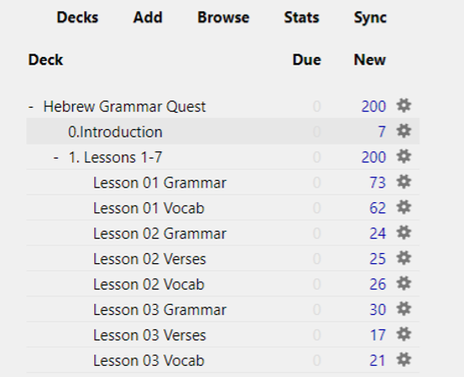

Figure 3.4: Anki Home Screen

Anki is free[55] flashcard application that contains a unique algorithm to present you with cards to review at just the right times.

Thus, it is not just a flashcard program but is a tremendous strength and endurance tool for learning, and it is where we will be spending the bulk of your time in the course. It has become the “go-to” for many medical school students to learn all the intricate facts they have to know.

## How to install Anki

While eventually, you can do all work from a mobile device, you do need to do the initial set up from a desktop. We’re not sure why, but this is how it is. Once you do this and then synch to the free Anki cloud, you’ll be off and running with mobile use.

1. Download and install the [free Ezra SIL font](https://software.sil.org/downloads/r/ezra/EzraSIL-2.51.zip)
2. [Sign up for a free account here](https://ankiweb.net/account/register)
3. [Download the Anki Program (Mac/PC/Linux)](https://apps.ankiweb.net/)

## Change some Anki Settings

1. Change USER1 Name
   1. In Anki, click File, then Switch Profile
   2. Select “User 1,” then Rename and type your name
2. Change global settings
   1. Click Tools, then Preferences.
      1. On the Basic tab, some people prefer night mode - if this is you, check the Night Mode box
      2. On the Scheduling tab:
         1. Check the box that says Anki 2.1 Scheduler.
         2. Note the hour the next day starts -
            * You want to set this for a time where you will NOT be doing reviews.
            * For most people, 4:00 am is a safe time, but if you’re routinely awake at 4:00 am, set this field to be earlier or later.

### Below is the main set you will want to change. Enter these numbers carefully:

1. Back on the main page, click the gear wheel to the right of “Hebrew Grammar Quest” and select “Options”
   1. Change settings on each tab to match this picture 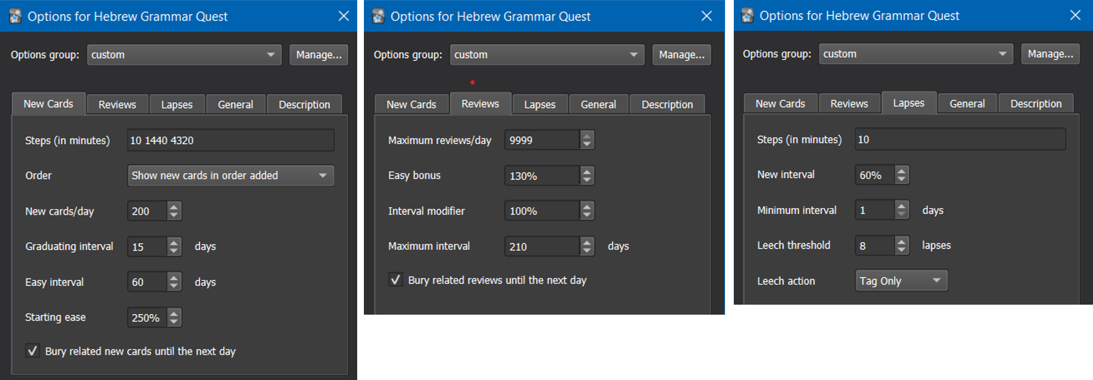

## [Download the Hebrew GRAMMAR Quest (Preview Version) Anki Deck](./images/Hebrew%20Grammar%20Quest%20PREVIEW.apkg)

## Navigating within Anki

* Click the +/- buttons to expand/collapse the folders within the Anki deck 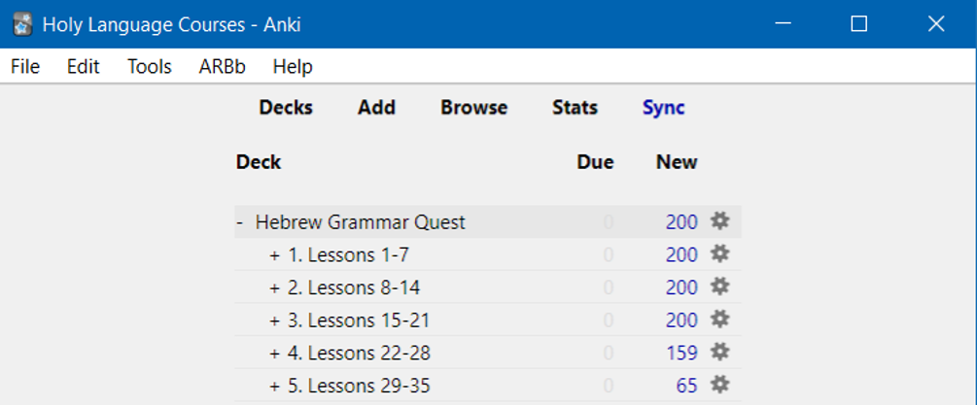
  + To start with Lesson 01 Vocabulary, expand to reveal this deck, click on Lesson 01 Vocabulary and click the STUDY NOW button
* Many cards have “hints” - click on the hint button to reveal
  + If you needed a hint, be sure to select Again on the answer side. See discussion below. 
* For cards that have audio, it should play when you are first shown the card. If you need to hear the audio again, hit the play button
* When you are ready to see the answer, click Spacebar, Enter, or the Show Answer button

## How do I know when to hit the Good button on a **Vocabulary** or **Grammar** card?

We suggest using the following guidelines to select the most appropriate answer.

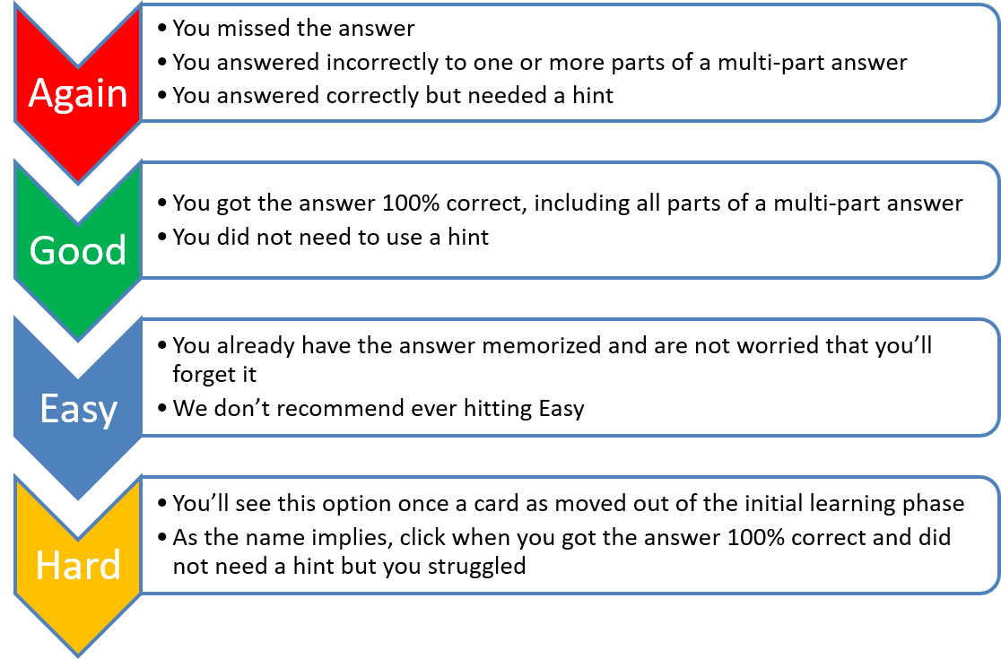

Figure 3.8: Anki Response Definitions

* There is no “value judgment” to hitting Again – you will learn on your timeline
* Be honest with yourself!
* If you doubt, between Again and Good, select Again.

## How do I know when to hit the Good button on a **Verse Translation** card?

While the same general guidelines apply to all cards, one of the main goals of this course is to give you the ability to translate from Hebrew to English at a basic level.

Below are some guidelines for answering the Verse Translation cards: * You do not necessarily need to be able to translate the entire passage from memory. Suppose you can comfortably read the Hebrew. Your translation is roughly similar to the English answer (it doesn’t have to be exact). In that scenario, you should hit good. 1. If your translation is missing one or more words (again excluding roughly equivalent meanings), you should select again. 1. If you need to use a hint, you should select again until you can translate without needing to refer to the hint. 1. We do not recommend selecting easy. An exception might be when you are confident that you already have the word, rule, or passage memorized.

Most importantly, be patient with yourself. It may take you many tries in the early going before you can hit good.

Learning a new language is not easy. We applaud you for the Hebrew learning road you are now taking!

## Anki Add-ons

* Add-ons are small packages that extend the base application of Anki.
* Many add-ons are geared towards the developers/editors of decks, but there are a few that enhance the end-user experience
* To access, select Tools, Add-ons, then click Get Add-ons...
* You will then be asked for the add-on code, which will install the add-on
* Click Browse Add-ons to be taken to the Anki Add-on website, where you can get the code
* For example, this add-on will change the button colors:
  + The KING of Button Add-ons - 374005964.

## How often should I expect to work in Anki?

The best case is DAILY.

Once you get going, you may find you look forward to it.

There is a custom add-on called Review Heatmap. At the time we are writing this Guidebook, the Add-on is still in beta, so it’s not available on the Anki Add-on page.

* [Click here to download](./images/review-heatmap-v1.0.0-beta.1-anki21.ankiaddon)
* Then double-click and restart Anki
* You will now see a grid that shows you your daily reviews to keep you motivated

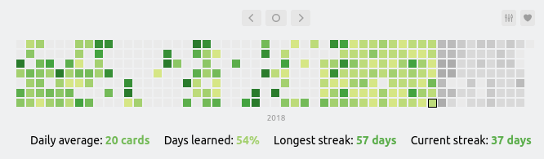

Figure 3.9: Keep your daily Anki streak going!

## Can I add an image or a hint?

* If you would like to edit a card, such as to add a picture or change/add a hint - you can do this. Just press E.
  + You can do this from either the “question” or the “answer” side of the card
  + We do not recommend you change the word, definition or audio fields
  + To add an image simply copy and paste into the image field 

## Can I modify the layout of a card?

The short answer is yes, but you would need to learn more about how Anki works. Such a discussion is beyond our scope with this book. Still, if you are interested in learning more about Anki, there are dozens of YouTube videos.

### Proceed with caution:

With the above caveat, if you are comfortable with Anki, we have added some extra Note Types.

1. Click Browse.
2. Select the card(s) you wish to change
3. If you want to be tested on both Hebrew-to-English and reverse, English-to-Hebrew, select note type Vocab Basic Hebrew/English.
4. If you have added images and want Anki to test you on Hebrew-to-English, English-to-Hebrew, and Image-to-Hebrew, select note type Vocab Basic Hebrew/English/Image.
5. If you have added images and only want to be tested on Hebrew-to-English and Image-to-Hebrew, select note type Vocab Basic Hebrew/Image.
6. If you want to be tested audio to Hebrew (and reverse), select note type Vocab Basic Hebrew/Audio - the Aleph-bet cards use this note type Just be aware that changing to one of these optional note types will double (or triple if you chose Hebrew/English/Image) the number of vocabulary cards. If you decide you want to go back to Hebrew-to-English, repeat steps 1-4 and select Note Type Vocab Basic Hebrew.

## What does There are more new cards available, but the daily limit has been reached mean?

Anki is doing precisely what we told it to do in the settings! As much as possible, we want to let Anki tell *us* when to work.

* We go when it tells us there are cards to learn or review
* We stop when it tells us there are no cards

1. We set new cards to 200 - it’s essential not to overload yourself.
   * Generally, if you work one deck at a time, e.g. Lesson 01 A. Vocab, then Lesson 01 B. Grammar and so on, you will be less likely to hit the daily limit
   * You can keep going using the Custom Study. Do note the warning: You can increase the limit in the options, but please bear in mind that the more new cards you introduce, the higher your short-term review workload will become.
2. We checked bury related cards.
   * If an answer has two parts in two separate questions, we want to make sure you answer the second question from your knowledge, not because you just saw the solution on a related card
   * If you want to work on these cards anyway, click Unbury.

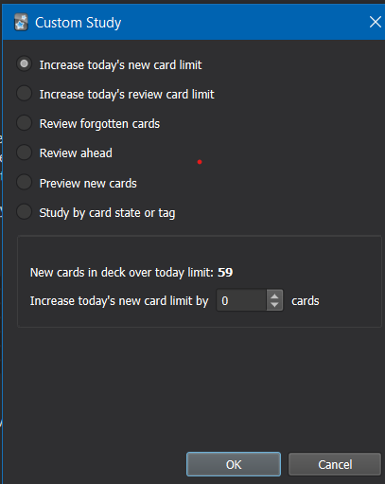

Figure 3.11: With Custom Study you can temporarily increase your daily new cards

# Appendix B: Questions and Answers about Hebrew GRAMMAR Quest

## What is the difference between Hebrew Quest and Hebrew GRAMMAR Quest?

* Both courses are born of the same Holy Language Learning philosophy: the optimal method to interact with the Sacred Scriptures is by *doing*
* Hebrew Quest was intentionally designed to get students into Hebrew texts with as little “grammar” as possible
* Hebrew GRAMMAR Quest is designed to fill a gap for those students who want to know more about the inner workings of Hebrew but wish to do so in a fun, low-pressure format (as opposed to taking a formal Hebrew course or trying to read an academic-level textbook on their own)
* Also, we know that everyone learns a little differently
  + Many can view the 40 lessons of Hebrew Quest, and they “get it” concerning Hebrew
  + Others may have found themselves getting stuck on the “grammar” sections of Hebrew Quest and need some more in-depth grammar preparation before returning to the study passages
  + Still others made it through some or all of Hebrew Quest and have a desire to know more
* As we said in the introduction, wherever you find yourself, if you are interested in digging deeper, you have come to the right place!

## Do I need to have completed Hebrew Quest before I start Hebrew GRAMMAR Quest?

* Emphatically - **No!**
  + This grammar course starts from the beginning (with learning the Aleph-bet) and assumes no prior knowledge of Hebrew
* With that said, the more of Hebrew Quest you have completed, the more comfortable you may find it is to work through the grammar material
* If we were to categorize as “good,” “better,” “best” in terms of Hebrew Quest completion, here’s what we would say:
  + **Good**:
    - You have completed some or no Hebrew Quest lessons
    - This means that the first three lessons of Hebrew GRAMMAR Quest might take you a little longer, but once you have that foundation, you’ll be up to speed
  + **Better**:
    - You have completed through Hebrew Quest Lesson 12 (the Aleph-bet and Vowels)
    - This means the first three lessons will go a little more quickly for you
  + **Best**:
    - You have completed through Lesson 15 (verbs) and beyond
    - This means that more of the concepts presented in Hebrew GRAMMAR Quest will tend to be things you have heard before versus brand new

## When I complete this course, should I go back and finish Hebrew Quest?

* **ABSOLUTELY!**
* In fact, the most logical next step after completing a first-year Hebrew grammar course is to dig into the Scriptures and start reading
* Hebrew Quest, starting with Lesson 16, is all about reading Hebrew[56]
* To say it differently, Hebrew Quest and Hebrew GRAMMAR Quest complement one another in a circular (and maybe slightly paradoxical!) form:
  + The more Hebrew Quest you have completed, the more you will get out of Hebrew GRAMMAR Quest, and
  + The more Hebrew GRAMMAR Quest you have completed, the more you will get out of Hebrew Quest
  + Either way, you can’t go wrong!

## I haven’t started either course. Which should I do first?

WHich one are you more interested in? It’s more important to pick one, jump in, and start learning Hebrew. * If the word “grammar” makes your stomach churn, then start with **Hebrew Quest**.  
* If you feel like you might want to build of a traditional foundation, then start with **Hebrew GRAMMAR Quest".

## I really don’t know. Can you just tell me where to start?

OK! Here’s a sequence we might recommend:

* Do the first 11 lessons of **Hebrew Quest** - this will take you in-depth through the Aleph-bet, not just academically but spiritually.
* After you learn the Aleph-bet, give **Hebrew Quest** Lessons 12-15 a try.
  + If the grammar pieces are clicking, then definitely go on to lesson 16 and the study passages. You always have the option starting this course at anytime.
  + Conversely, we’ve found that a lot of folks get stuck on these lessons If this is you, then know you’re one of the reasons we designed this grammar course. You might want to pause **Hebrew Quest**, and immediately jump into **Hebrew GRAMMAR Quest**

Whichever direction you take, we would encourage you to ultimately complete both **Hebrew Quest** and **Hebrew GRAMMAR Quest**.

## There are many books out there to learn Hebrew. What makes Hebrew GRAMMAR Quest different?

* As we say above, we want students to learn by **doing**
  + While **Hebrew GRAMMAR Quest** will cover the same concepts as a typical first-year Hebrew textbook, the instructional design team at Holy Language Institute are big proponents of *active* learning as opposed to passive learning
  + Reading a book is mostly a passive activity
  + Therefore, our goal for this interactive, self-contained book is to provide a quick orientation to the concepts[57]
* Textbooks have their place, but in our view, your “real” learning will take place when you complete the ACTIVities (see the root of the word “active” in there?)
  + This is the impetus behind the current “flipped classroom” philosophy in traditional education

## What is a “flipped classroom”?

* Hebrew GRAMMAR Quest applies concepts from what is called a “flipped classroom.”
* In a traditional classroom, lecture and exams are the priority
  + What educators have started to notice was that these two aspects of teaching, though valuable for different reasons, are not when the student’s primary learning occurs
* In a flipped classroom, the activities usually thought of as “homework” are the priority
  + Interactive reading (with note-taking and active-recall), worksheets, and discussion are much better vehicles for learning than a lecture
* Therefore, there is a deliberate emphasis on activities over lectures, assigned reading, and exams. To emphasize this emphasis, we call these “**ACTIV**ities”!

## What are the ACTIVities?

We cover all of this in the Preface: this book’s philosophy and direction section!

## How do I access the Anki deck?

### [Download the Hebrew GRAMMAR Quest (Preview Version) Anki Deck](./images/Hebrew%20Grammar%20Quest%20PREVIEW.apkg)

* The full program including all 35 Lessons in this book and the complete Anki package will be are available to subscribers of Holy Language Institute in 2021

## Will I need to buy anything?

* **NO**. Other than being a subscriber to Holy Language Institute, you will not need to purchase anything for this course (unless you want to)
* We would like to disclose that the iOS version of the Anki app requires a one-time purchase through the Apple store of $25
  + Note: Holy Language Institute has nothing to do with this policy and receives nothing should you decide to purchase the app
  + The developers of Anki provide every other platform for free and say they use the proceeds from the iOS app to fund these different platforms and program enhancements
  + While the price is steep for an app, most online reviews say the cost is justified (a few pennies a day over a year)
  + If you have an Apple device and do not wish to purchase the app, you may use a web-based version of mobile Anki at no charge (you won’t be able to use it offline)
* There are lots of additional resources available that accompany Basics of Biblical Hebrew for free and to purchase - we will incorporate many of the free resources into this book package
* In other words, we have designed this book so that you should not need to purchase any additional learning materials
* With that said, if you wish to purchase *Basics of Biblical Hebrew* or any of the accompanying resources for a more in-depth Grammar study, some options are below[58]
  + [Basics of Biblical Hebrew Textbook](https://www.amazon.com/gp/product/031053349X/&tag=holylanginst-20)
  + [Basics of Biblical Hebrew Workbook](https://www.amazon.com/gp/product/0310533554/&tag=holylanginst-20)
  + [Basics of Biblical Hebrew Laminated Reference Card](https://www.amazon.com/gp/product/031026295X/&tag=holylanginst-20)
  + We would appreciate it if you would use one of the affiliate links, which allows Holy Language Institute to receive a small commission

## Who will (and who might not) benefit from Hebrew GRAMMAR Quest?

* Hebrew GRAMMAR Quest is focused on reading and understanding Hebrew for the English speaker
  + If you desire to read the Hebrew Scriptures in the original language and have a greater comprehension of what you read, this course is for you!
  + If one was looking to be a fluent writer or speaker[59] of Hebrew, or teach Hebrew in a formal academic setting, this course probably would not fully meet that person’s goals (although it would be a terrific first step)
* This course focuses on Biblical Hebrew, not Modern Hebrew
  + If you are looking to translate “can you direct me to the railway station?”, we apologize, but this course will not benefit you!
* Hebrew GRAMMAR Quest is designed to be self-directed and (mostly) stress-free
  + By design, it does not have the accountability and rigor of a traditional academic program
    - By saying it does not have “academic rigor,” we are **NOT** saying this course will be **easy**
    - You will likely spend *many* hours on this course, mostly in Anki
    - We believe it will be a tremendous investment you can make for the kingdom and the impact you can have on others
    - When you start to see your knowledge building up in Anki, we believe you will find it rewarding and perhaps even fun as well
  + Those who are seeking more of an academic/seminary type of setting might fare better with a traditional, instructor-led, Hebrew course

### What if I am a Bible teacher? Should I take this course?

* We believe this course, in conjunction with **Hebrew Quest**, would prepare a pastor or teacher of a traditional Christian congregation to have a basic understanding of the Hebrew text to be able to exegete and communicate beginning and intermediate level Hebrew/Hebraic concepts to a lay audience
  + Additionally, for those who have had first-year Hebrew at seminary (perhaps many years ago) but have struggled to apply knowledge of the original language to their vocation, or for those pastors/teachers who may have never taken a grammar course in Hebrew, ***our prayer is that this course, along with Hebrew Quest, will give new life to Hebrew application in that person’s teaching ministry***[60]

# About Holy Language Institute



***Jesus is Jewish.***

What if you could get closer to him through Hebrew?

Read on to see what “Following Yeshua, in a Hebrew way, together” means to us.

## Following Yeshua

When the first disciples heard “follow me”, they understood they were being invited into a relationship with this Rabbi from Nazareth. Through this journey of discipleship they would become like him and go on to change the world with him. They knew that following Yeshua was all about knowing Yeshua. That’s what our learning experiences are all about.

## In a Hebrew Way

The disciples of Jesus joined him in reading the Hebrew Bible and praying the Hebrew prayers. That’s why this isn’t just a language - it’s a way of following in the footsteps of the Master, a way of encountering the King of the Jews through the language of his people.

## Together

The men and women who followed Yeshua became a safe and loving community. Same with us! As an organization we’re Holy Language “Institute”. As a community of disciples we’re the Holy Language “Tribe”. Together we’re a movement, making disciples and changing the world.

***LEARN MORE:***

[Email sign-up](https://holylanguage.com/index.html)

[Become a member](https://holylanguage.com/subscribe.html) to access the full Hebrew GRAMMAR Quest course, as well as our complete library of teaching materials.

# About the designer of this book

* Chris Flanagan has been a member of HLI since 2013 and joined as a ministry volunteer in 2015.
* He has completed Hebrew Quest as a student, which planted a desire to dig deeper into the original languages. He has completed both Hebrew and Greek courses at the seminary level.
* He has worked on a number of projects for HLI from an instructional design standpoint, including leading of “Hebrew Quest Memrise” and now “Hebrew Grammar Quest”
  + This work is simply a compilation of many various first-year Hebrew resources, which he has knitted together to present in an original and engaging format
  + For this reason, he likes to refer to himself as the “designer” or “compiler” of this dynamic Hebrew learning tool, and not the “author” of a static book
* Professionally, Chris has worked in the healthcare compliance field for over 30 years
* Personally, Chris is married and has two men in college. He and his wife, Sarah, love to travel, especially to Israel; (which, as you can tell, has inspired the format of each lesson in this book)



image

# Acknowledgments

All honor and glory to Yeshua, our Lord. שֵׁם יְהוָה אֶקְרָא

Unless, otherwise noted, English Scripture quotations taken from the NASB. Copyright by The Lockman Foundation. Used by permission.

Biblical Hebrew text is courtesy of tanach.us (version 26.0).

Our thanks to Dr. Gary Pratico and Dr. Myles Van Pelt for Basics of Biblical Hebrew, the seminary textbook that inspired the format of **Hebrew Grammar Quest**. We encourage any of our students who wish to go further with Hebrew grammar to purchase the textbook or any related materials.

Additionally, our thanks to Dr. John Beckman for making his extensive library of materials to accompany Basics of Biblical Hebrew freely available for reuse under CC-BY-SA.

As applicable:

* Vocabulary portions of this book are derivatives of [00_vocabulary.pdf](https://hebrewsyntax.org/bbh2new/00_vocabulary.pdf) by John Beckman, used under [CC-BY-SA](https://creativecommons.org/licenses/by-nc-sa/4.0/).
* Grammar portions of this book are derivatives of [00_study_guide.pdf](https://hebrewsyntax.org/bbh2new/00_study_guide.pdf) as well as the “overhead” files for each chapter (for example [Chapter 1-The Hebrew Alephabet](https://hebrewsyntax.org/bbh2new/01_overheads_bw.pdf), and so on for each successive chapter) by John Beckman, used under [CC-BY-SA](https://creativecommons.org/licenses/by-nc-sa/4.0/).
* Study verses portions of this Anki deck are derivatives of [00_workbook_answers.pdf](https://hebrewsyntax.org/bbh2new/00_workbook_answers.pdf) by John Beckman, used under [CC-BY-SA](https://creativecommons.org/licenses/by-nc-sa/4.0/).

Finally, we thank YOU for your interest in this course!

# License

© 2021 Holy Language Institute. All rights reserved.



Creative Commons

This work is licensed under the Creative Commons Attribution-NonCommercial-ShareAlike 4.0 International License.

This license is for personal use only. This publication may not be downloaded, redistributed, re-uploaded, published, or used for any other purposes without explicit permission from the copyright holder.

If you received this book and you are not a member of Holy Language Institute, [become a member](https://holylanguage.com/subscribe.html) today! Subscribing will give you access to the full Hebrew GRAMMAR Quest course, as well as our complete library of teaching materials.

1. Refer to Hebrew Quest, Lesson 1.
2. Stiles, Wayne. “How to Prepare for a Holy Land Tour.” Wayne Stiles. February 20, 2013. <https://waynestiles.com/how-to-prepare-for-a-holy-land-tour/>. Accessed September 28, 2020.
3. We are your Hebrew grammar tour guide. This is why why we are calling this a “guidebook” instead of a “textbook”!
4. The lesson format generally follows that of Basics of Biblical Hebrew by Dr. Gary Pratico and Dr. Myles Van Pelt. We make extensive use of derivative works by Dr. John Beckman, whose material accombanying Basics of Biblical Hebrew is freely available under the Creative Commons (CC-BY-SA) license.
5. “The Fog” is a term coined by Dr. Bill Mounce, author of Basics of Biblical Greek.
6. By this we mean the *scheduling* and *queuing* of items to review is automatic. You still need to do the work!
7. Philippians 4:6-7 (NASB) Be anxious for nothing, but in everything by prayer and supplication with thanksgiving let your requests be made known to God. 7 And the peace of God, which surpasses all comprehension will guard your hearts and your minds in Yeshua our Messiah.
8. 2 Timothy 3:16-17 (NASB) All Scripture is inspired by God and profitable for teaching, for reproof, for correction, for training in righteousness; 17 so that the man of God may be adequate, equipped for every good work.
9. 1 Thessalonians 5:11 (NASB) Therefore, encourage one another and build up one another, just as you also are doing.
10. Only one badge is available in the preview version of the course.
11. Not available in the preview version of the course.
12. Why not complete both Hebrew Quest and Hebrew GRAMMAR Quest so you can earn the lamp **AND** the mug!
13. Valci, Roger. “The Hebrew Acrostic,” in Basics of Biblical Hebrew: Grammar, edited by Gary D Pratico and Miles V Van Pelt. Grand Rapids, MI: Zondervan. 2007.
14. This graphic shows the evolution of Hebrew. Top to bottom: proto-Canaanite (~1600 BCE), paleo-Hebrew (~900 BCE), Rashi (1500 CE), Ketav Stam (used in Torah scrolls and other formal documents), contemporary block, and modern cursive. This course will use the contemporary block style. For more history and discussion on the other script forms, see Hebrew Quest, lessons 2-11.
15. *Sofit* is just the Hebrew word for final
16. “Final Kaf,” “Final Mem,” etc., are also terms you may hear.
17. See also Lesson 3 of Hebrew Quest
18. If you see a dot in a letter other than these six, then you know it can’t be a Daghesh Lene
19. You will learn the specific differences in your Anki work for this lesson.
20. “Seminary Hebrew” is a term borrowed from Dr. John Beckman. We don’t say “Seminary Hebrew” to be disrespectful; we only mean to differentiate between the two pronunciation types.
21. With “Seminary Hebrew,” the ג without the Daghesh Lene receives something like the GH in “aGHast.” The ד and ת without the Daghesh Lene are closer to the English TH like “this.”
22. Pronouncing/writing/transliterating the Holy Name of God tends to be much more common in Christian academic circles. If you were to read “Basics of Biblical Hebrew,” you would see the name “Y–w-h” frequently. We do know of academians, such as Dr. John Beckman and Dr. Robert Cargill, who will use the circumlocution of respect instead of pronouncing the name (and request their students do the same), so this is not a hard and fast “academic” distinction
23. Click the link (and sign in with a Google account if necessary), then click “Open with Google Docs” to highlight the letters.
24. The color is to let you know what color the answer key will use, but feel free to highlight in any color, underline, change the font color, or otherwise identify anyway you like.
25. Warfield, Benjamin Breckenridge. “The Languages of Pastoral Ministry,” in Basics of Biblical Hebrew: Grammar, edited by Gary D Pratico and Miles V Van Pelt. Grand Rapids, MI: Zondervan. 2007 B.B. Warfield was a Presbyterian minister and professor of theology at Princeton Seminary from 1887 to 1921. ([wikipedia link](https://en.wikipedia.org/wiki/B._B._Warfield))
26. As Izzy says in Hebrew Quest, “Vowels are important.” On your screen, you see Genesis 1:9. The black font shows the text with no vowels. Over time, a group known as the Masorites developed the vowel notation we use today. These are the symbols in red. These are usually under, but sometimes in the middle of or over the affected consonant. This vowel system intends to preserve the pronunciation passed down for centuries via the oral tradition. The Hebrew name for these diacritical dots and dashes is *nikudot*. The blue font shows additional cantillation marks, which synagogues use for chanting the verses. These marks also show where the word’s accent is.  
    Image Source: Originally uploaded as en:<File:Example> of biblical Hebrew trope.svg on 04:27, 19 November 2006 (UTC) by en:User:SyntaxError55.
27. We will learn that Hebrew loves to break the rules. In the next lesson, we will learn about an exception to the “vowel comes after” rule, called the *furtive patach*.
28. Most academic textbooks will use the term “Shewa” instead of “Sheva”.
29. We’ll explain what this means in the next lesson
30. “Defective”, in this sense, does not have a negative connotation.
31. Mayim is one syllable as we will learn in Lesson 3. הַשָּׁמַיִם means “the heavens.” From now on, we won’t always provide a translation for every new word you encounter. It’s more important that you focus on the concepts. You will have PLENTY of vocabulary work in Anki!
32. The * means this is not a real Hebrew word, but we show it in this form for illustration.
33. Not entirely unlike the English apostrophe in words like *can’t*.
34. Remember the rule for the Daghesh Lene? See Lesson 1.4
35. Strictly speaking, there are exceptions, but you won’t encounter them in a first-year Hebrew course
36. Yes, a patach. Daghesh Forte
37. No. Daghesh Lene
38. No. Daghesh Lene. The “hyphen” looking mark is called a Maqquef. It has the exact same function as the Hyphen does in English.
39. No, it is preceded by a Sheva. Daghesh Lene.
40. Yes, a Hiriq. Daghesh Forte
41. ignore the “transliteration” column. An answer key is on page two. Repeat this worksheet until you can complete it correctly entirely from memory.
42. In most word processors, you won’t be able to isolate the vowel to highlight. Get as close as you can.
43. The other vowels that use hei are less common, but we will see them when we discuss verbs.
44. We haven’t learned to spot Qamets Hatuf yet, and Qibbuts does not appear in this passage
45. You should be able to make out the word that has the Hateph Qamets Hatuph
46. In at least three of the cases, you should be able to figure out who is speaking.
47. Once published, the full 35-Lesson course will have a badge to be claimed after every 2-3 Lessons. There is only one badge available in the preview version of the course.
48. The Tel Dan Stele was a significant archaeological find of the late 20th century. Written in Aramaic, closely related to Hebrew, the carving dates to the 9th Century BCE. It is notable for containing a reference to the “house of David.” It is the earliest known extra-biblical reference to King David. Before its discovery, many scholars had cast doubt on whether David existed. Archeologists discovered it at “Dan” near the Lebanon border in modern Israel. (Photo Credit: By Oren Rozen - Own work, CC BY-SA 4.0, <https://commons.wikimedia.org/w/index.php?curid=47055869>)
49. Modern Hebrew has words (mostly borrowed from other languages) that don’t follow this rule
50. Hebrew has a very elaborate system of [cantillation marks](https://en.wikipedia.org/wiki/Hebrew_cantillation) that also serve to indicate where the accent of the word is. are used for chanting and singing. A study of these marks is beyond the scope of this book.
51. Additional info in the textbook that you don’t need to know: 1) If there is a syllable AFTER the accented syllable, technically it is called “Posttonic,” but you will not reencounter this term for the remainder of this course. 2) There is an additional set of words that signifies a syllable’s position irrespective of the accent: *ultima* = the last syllable; *penultima* is the next to last syllable; *antepenultima* is the syllable before the *penultima*
52. A Sheva at the **end** of a word is **always silent**, even when it is the second of two consecutive Shevas.
53. These vowels often but do not always reduce (see section 3.6). Unchangeable long vowels will never reduce.
54. A Sheva that appears under the initial consonant of a word is always vocal, and a Sheva that appears under the final consonant of a word is always silent.
55. all platforms are free, except for the iOS app, which costs $25. The developers use the proceeds to fund future development. Most reviews say the cost is worth it if you have Apple devices and use Anki regularly.
56. Although, with your more in-depth knowledge, you may be able to go a little faster. If the Hebrew Quest videos are too slow for you, click the “Settings” gear icon in the bottom right corner of the video, click “Speed,” and then select a faster speed.
57. If you’re looking for a stand-alone textbook, there is none better than Basics of Biblical Hebrew.
58. Before purchasing, we would like to make our students aware that the authors of these materials take an academic, as opposed to a reverential approach regarding God’s Holy Name. You will see the transliteration of the Tetragrammaton printed on nearly every page. While we believe this is unfortunate and unnecessary, Basics of Biblical Hebrew remains an excellent resource for an in-depth study of first-year Hebrew grammar.
59. There are speaking activities beginning with Lesson 3, but this is more to engage additional senses in the learning process and not to become a fluent reader.
60. This book’s author can testify to this!